AKN4ZH/ELI4CH

Namenskonventionen für IRI

AKN4ZH folgt den Naming Convention von Akoma Ntoso.
ELI4CH folgt den Naming Conventions von Fedlex (inspieriert von ELI).

URI-Namenskonventionen

<bill> (Entwurf)

KTZH (grundsätzlich relative IRI (gemäss RFC3968) für einfachen Base-URL-Wechsel in Zukunft oder mehrere URLs mit gleichen Erlassen (die URI im AKN-Dokument funktionieren so auch immer), alle Entwürfe; gesetzlich vorgeschriebene Ausleitungen in AKN-Element <publication> deklariert):
WORK IRI
Fachlich: /Konvention/Jurisdiktion/Typ (Entwurf)/Jahr-Nummer Rechtsetzungsprojekt
Bsp.: /akn/CH-ZH/bill/2025-567

EXPRESSION IRI
Fachlich: /Konvention/Jurisdiktion/Typ (Entwurf)/Jahr-Nummer Rechtsetzungsprojekt/Sprache@Versionsnummer
Bsp.: /akn/CH-ZH/bill/2025-567/deu@3-5
MANIFESTATION IRI
Fachlich: /Konvention/Jurisdiktion/Typ (Entwurf)/Jahr-Nummer Rechtsetzungsprojekt/Sprache@Versionsnummer.Dateiformat für spezifische Ausleitung (wenn für alle Formate ein Dokument, dann *.akn)
Bsp.: /akn/CH-ZH/bill/2025-567/deu@3-5.akn
BUND (grundsätzlich absolute IRI, nur für Vernehmlassungsentwurf):

WORK IRI
Fachlich: fedlex-Domäne/Konvention/eli draft-legislation /proj für Rechtsetzungsprojekt)/Jahr/Nummer Rechtsetzungsprojekt
Bsp.: https://fedlex.admin.ch/eli/dl/proj/202/567
EXPRESSION IRI
Fachlich: fedlex-Domäne/Konvention/eli draft-legislation /proj für Rechtsetzungsprojekt)/Jahr/Nummer Rechtsetzungsprojekt/???
Bsp.: https://fedlex.admin.ch/eli/dl/proj/202/567/???
MANIFESTATION IRI
Fachlich: fedlex-Domäne/Konvention/eli draft-legislation /proj für Rechtsetzungsprojekt)/Jahr/Nummer Rechtsetzungsprojekt/???
Bsp.: https://fedlex.admin.ch/eli/dl/proj/202/567/???

<act> (Grunderlass inkl. konsolidierte Fassungen als Versionen (Point in Time))

KTZH (grundsätzlich relative IRI (gemäss RFC3968)):
WORK IRI
Fachlich: /Konvention/Jurisdiktion/Typ (Erlass) /BeschlussdatumGrunderlass/NummerGrunderlassInOS
Bsp.: /akn/CH-ZH/act/2024-02-29/2024-17

EXPRESSION IRI
Fachlich: /Konvention/Jurisdiktion/Typ (Erlass) /Beschlussdatum(Grund-)erlass/Nummer(Grund-)erlassInOS/Sprache@DatumInkrafttreten
Bsp. OS (AS): /akn/CH-ZH/act/2024-02-29/2024-17/ger@
(AKN:<FRBRauthoritative value=”true”/>)
Bsp. LS (SR): /akn/CH-ZH/act/2024-02-29/2024-17/ger@2026-01-01
(AKN:<FRBRauthoritative value=”false”/>)

MANIFESTATION IRI
Fachlich: /Konvention/Jurisdiktion/Typ (Erlass) /BeschlussdatumGrunderlass/NummerGrunderlassInOS/Sprache@DatumBeschlussErlass/NummerErlassInOS.Dateiformat der auf vorliegendem XML beruhenden Ausleitung nach z.B. DOCX, PDF etc. Wenn gleiches XML für alle Ausleitungen, dann immer *.akn.
Bsp. OS: /akn/CH-ZH/act/2024-02-29/2024-17/ger@.akn
Bsp. LS: /akn/CH-ZH/act/2024-02-29/2024-17/ger@2026-01-01.akn
HTTP-Resolver: https://zhlex.zh.ch/akn/CH-ZH/act/2024-02-29/2024-17/ger führt zur aktuellen konsolidierten Fassung in der angegebenen Sprache. URL ohne Sprachangabe zur aktuellen Fassung in der Sprache gemäss Browsereinstellung.

BUND (grundsätzlich absolute IRI):
WORK IRI
Der Bund führt für die beiden Sammlungen und Fassungen unterschiedliche WORKs.
Fachlich AS: /Konvention/Sammlung/NummerGrunderlassInAS
Fachlich SR: /Konvention/Sammlung/NummerGrunderlassInAS/DatumInkrafttreten(Änderungen)
Bsp. AS: /eli/oc/2022/491
Bsp. SR: /eli/cc/2022/491/20250707
EXPRESSION IRI
Fachlich AS: /Konvention/Sammlung/NummerGrunderlassInAS/Sprache
Fachlich SR: /Konvention/Sammlung/NummerGrunderlassInAS/DatumInkrafttreten(Änderungen) /Sprache
Bsp. AS: /eli/oc/2022/491/de
Bsp. SR: /eli/cc/2022/491/20250707/de
MANIFESTATION IRI
Fachlich AS: /Konvention/Sammlung/NummerGrunderlassInAS/Sprache/Dateiformat vorliegendes XML
Fachlich SR: /Konvention/Sammlung/NummerGrunderlassInAS/DatumInkrafttreten(Änderungen) /Sprache/ Dateiformat vorliegendes XML
Bsp. AS: /eli/oc/2022/491/de/xml
Bsp. SR: /eli/cc/2022/491/20250707/de/xml

R3 is realised in
(realises)
frbroo: F1_Work
frbroo: F22_Self-Contained_Expression
based on
frbroo
R4 carriers provided by (comprises carriers of)
(realises)
based on
frbroo: F3_Manifestation_Product_Type

based on
based on
based on
Akn/(SLI)
Work

Manifestation
Expression
based on
based on
based on
is_realized_by [1..n] (realizes)
is_embodied_by [1..n] (embodies)
ELI/SLI
Format
LegalExpression
LegalResource

FRBRoo V. 2.4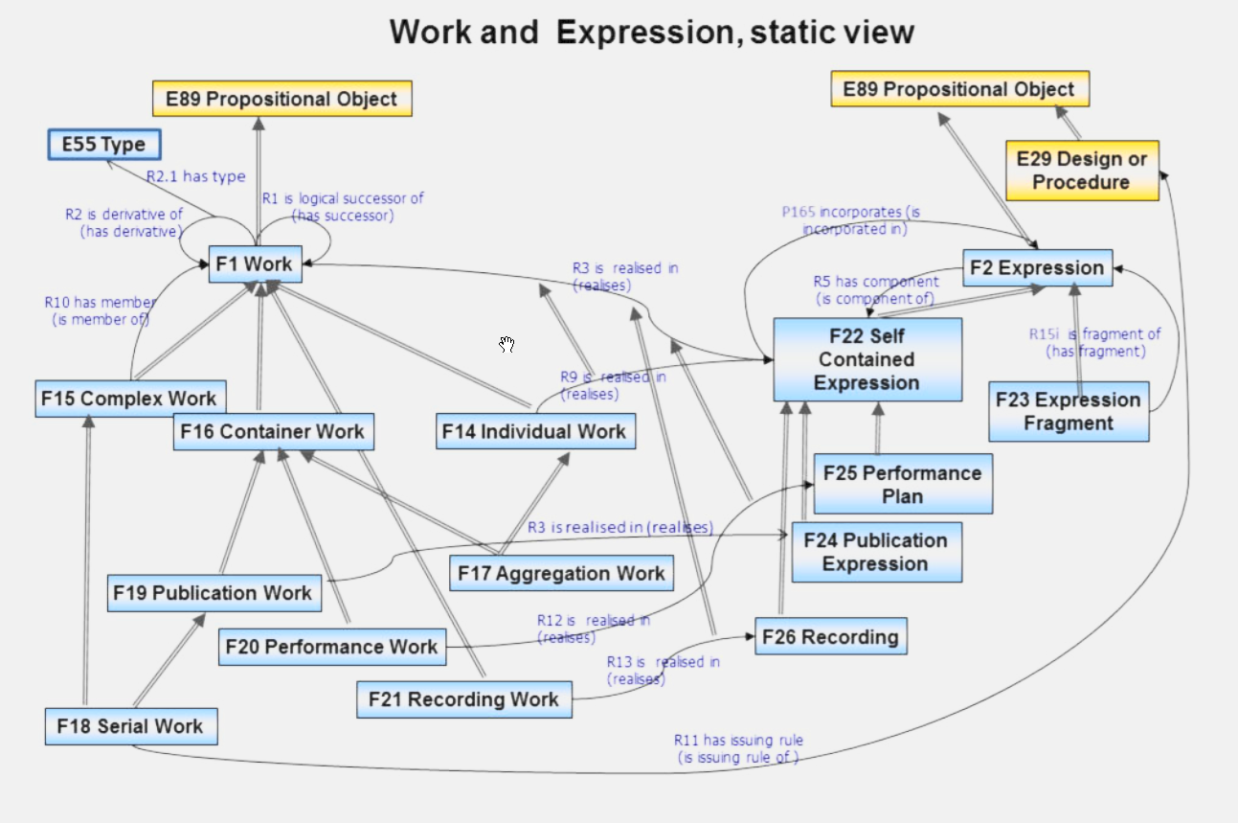

FRBR-Definitionen von F1 und F22

F1 Work
Subclass of: E89 Propositional Object
Superclass of: F14 Individual Work
F15 Complex Work
F16 Container Work
F21 Recording Work
Scope note: This class comprises distinct concepts or combinations of concepts identified in artistic and intellectual expressions, such as poems, stories or musical compositions. Such concepts may appear in the course of the coherent evolution of an original idea into one or more expressions that are dominated by the original idea. A Work may be elaborated by one or more Actors simultaneously or over time. The substance of Work is ideas. A Work may have members that are works in their own right.
A Work can be either individual or complex. If it is individual its concept is completely realised in a single F22 Self-Contained Expression. If it is complex its concept is embedded in an F15 Complex Work. An F15 Complex Work consists of alternative members that are either F15 Complex Works themselves or F14 Individual Works.
A Work is the product of an intellectual process of one or more persons, yet only indirect evidence about it is at our hands. This can be contextual information such as the existence of an order for a work, reflections of the creators themselves that are documented somewhere, and finally the expressions of the work created. As ideas normally take shape during discussion, elaboration and implementation, it is not reasonable to assume that a work starts with a complete concept. In some cases, it can be very difficult or impossible to define the whole of the concept of a work at a particular time. The objective evidence for such a notion can only be based on a stage of expressions at a given time. In this sense, the sets of ideas that constitute particular self-contained expressions may be regarded as a kind of “snap-shot” of a work.
A Work may include the concept of aggregating expressions of other works into a new expression. For instance, an anthology of poems is regarded as a work in its own right that makes use of expressions of the individual poems that have been selected and ordered as part of an intellectual process. This does not make the contents of the aggregated expressions part of this work, but only parts of the resulting expression.
Examples: Abstract content of Giovanni Battista Piranesi’s ‘Carcere XVI: the pier with chains: 1st state’ (F14)
‘La Porte de l’Enfer’ by Auguste Rodin conceived between 1880 and 1917 (F15)
‘Hamlet’ by William Shakespeare (F15)

Properties: R1 is logical successor of (has successor): F1 Work
R2 is derivative of (has derivative): F1 Work (R2.1 has type: E55 Type)
R3 is realised in (realises): F22 Self-Contained Expression
R40 has representative expression (is representative expression for): F22 SelfContained Expression
F22 Self-Contained Expression
Subclass of: F2 Expression
Superclass of: F24 Publication Expression
F25 Performance Plan
F26 Recording
Scope note: This class comprises the immaterial realisations of individual works at a particular time that are regarded as a complete whole. The quality of wholeness reflects the intention of its creator that this expression should convey the concept of the work. Such a whole can in turn be part of a larger whole.
Inherent to the notion of work is the completion of recognisable outcomes of the work. These outcomes, i.e. the Self-Contained Expressions, are regarded as the symbolic equivalents of Individual Works, which form the atoms of a complex work. A Self-Contained Expression may contain expressions or parts of expressions from other work, such as citations or items collected in anthologies. Even though they are incorporated in the Self-Contained Expression, they are not regarded as becoming members of the expressed container work by their inclusion in the expression, but are rather regarded as foreign or referred to elements.
F22 Self-Contained Expression can be distinguished from F23 Expression Fragment in that an F23 Expression Fragment was not intended by its creator to make sense by itself. Normally creators would characterise an outcome of a work as finished. In other cases, one could recognise an outcome of a work as complete from the elaboration or logical coherence of its content, or if there is any historical knowledge about the creator deliberately or accidentally never finishing (completing) that particular expression. In all those cases, one would regard an expression as selfcontained.
Examples: The Italian text of Dante’s ‘Inferno’ as found in the authoritative critical edition La Commedia secondo l’antica vulgata a cura di Giorgio Petrocchi, Milano: Mondadori, 1966-67 (= Le Opere di Dante Alighieri, Edizione Nazionale a cura della Società Dantesca Italiana, VII, 1-4)
The musical notation of Franz Schubert’s lied known as ‘Ave Maria’
The musical notation of Franz Schubert’s lieder cycle entitled ‘Seven Songs after Walter Scott’s The Lady of the Lake’, of which ‘Ave Maria’ is a distinct part
The musical notation of Franz Liszt’s piano transcription of Franz Schubert’s lied known as ‘Ave Maria’
The musical notation of fragments of the unfinished string quartet sketched by Arnold Schoenberg

Abgrenzung Original - New Expression/New Work

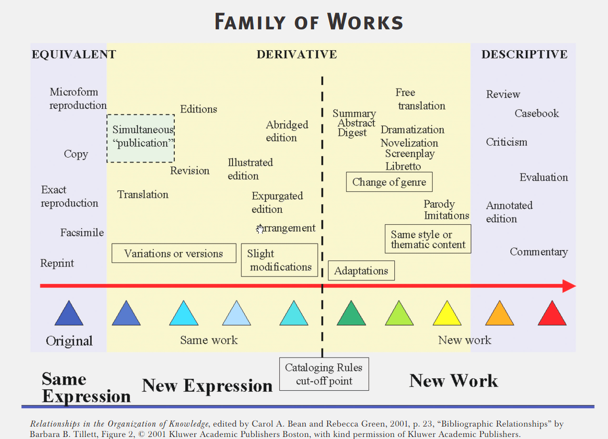

FRBR in AKN:

(a) Work – the abstract concept of the legal resource (e.g., act 3 of 2015).
AKN4ZH: Abstrakte Idee von Regelungen in einem bestimmten Bereich in Form eines Erlasses z.B. Datenschutz, Strassenverkehr etc. (Grunderlass) oder Änderung des Datenschutzes mit der Idee, den Datenschutz bezüglich KI zusätzlich zu regulieren (Änderungserlass), etc.
(b) Expression - any version of the Work whose content is specified and different from others for any reason: language, versions, etc. (e.g., act 3 of 2015 as in the version following the amendments entered into force on July 3rd, 2016).
AKN4ZH: Jede Fassung eines Erlasses (Grunderlass und konsolidierte Fassungen/Versionen) / Änderungserlass / Mantelerlass / Aufhebungserlass)
(c) Manifestation - any electronic or physical format of the Expression: MS Word, Open Office, XML, TIFF, PDF, etc. (e.g., PDF representation of act 3 of 2015 as in the version following the amendments entered into force on July 3rd, 2016).
AKN4ZH: Alle Format-Ausleitungen (PDF, DOCX, XML etc.) basieren auf einem einzigen AKN-XML-Dokument, weshalb AKN für die Bezeichnung des Formats verwendet wird.
ELI4CH: Der Bund verwendet im XML ebenso XML für das Format, weil das AKN-XML vielmehr eine Ausleitung aus Word ist, angereichert mit Metadaten aus Jolux.

ELI Naming Convention
